SOURCE DB CHECK BACKUPS:

RMAN> list backup summary;

List of Backups
===============
Key TY LV S Device Type Completion Time #Pieces #Copies Compressed Tag
------- -- -- - ----------- --------------- ------- ------- ---------- ---
1 B F A DISK 03-MAR-23 1 1 NO TAG20230303T144339
2 B F A DISK 21-JUL-23 1 1 NO TAG20230721T181148
3 B AA DISK 24-JUL-23 1 1 YES TAG20230724T235535
4 B AA DISK 24-JUL-23 1 1 YES TAG20230724T235535
5 B AA DISK 24-JUL-23 1 1 YES TAG20230724T235535
6 B F A DISK 24-JUL-23 1 1 YES TAG20230724T235538
7 B F A DISK 24-JUL-23 1 1 YES TAG20230724T235538
8 B F A DISK 24-JUL-23 1 1 YES TAG20230724T235538
9 B F A DISK 24-JUL-23 1 1 YES TAG20230724T235538
10 B F A DISK 24-JUL-23 1 1 YES TAG20230724T235538
11 B F A DISK 25-JUL-23 1 1 YES TAG20230724T235538
12 B F A DISK 25-JUL-23 1 1 YES TAG20230724T235538
13 B F A DISK 25-JUL-23 1 1 YES TAG20230724T235538
14 B AA DISK 25-JUL-23 1 1 YES TAG20230725T000311
15 B F A DISK 25-JUL-23 1 1 NO TAG20230725T000312
16 B AA DISK 25-JUL-23 1 1 YES TAG20230725T001349
17 B AA DISK 25-JUL-23 1 1 YES TAG20230725T001349
18 B AA DISK 25-JUL-23 1 1 YES TAG20230725T001349
19 B AA DISK 25-JUL-23 1 1 YES TAG20230725T001349
20 B AA DISK 25-JUL-23 1 1 YES TAG20230725T001349
21 B 0 A DISK 25-JUL-23 1 1 YES TAG20230725T001352
22 B 0 A DISK 25-JUL-23 1 1 YES TAG20230725T001352
23 B 1 A DISK 25-JUL-23 1 1 YES TAG20230725T001352
24 B 1 A DISK 25-JUL-23 1 1 YES TAG20230725T001352
25 B 1 A DISK 25-JUL-23 1 1 YES TAG20230725T001352
26 B 1 A DISK 25-JUL-23 1 1 YES TAG20230725T001352
27 B 1 A DISK 25-JUL-23 1 1 YES TAG20230725T001352
28 B AA DISK 25-JUL-23 1 1 YES TAG20230725T002059
29 B F A DISK 25-JUL-23 1 1 NO INCR1_CTL
30 B F A DISK 25-JUL-23 1 1 NO INCR1_SPFILE
31 B F A DISK 25-JUL-23 1 1 NO TAG20230725T002104
32 B AA DISK 25-JUL-23 1 1 YES TAG20230725T002718
33 B F A DISK 25-JUL-23 1 1 NO TAG20230725T002721

Copy RMAN (Full backup, Incremental Backup &Archivelog)backups to target server

Note : Compare Source and target pfile and compare

Check DBS location as below:

[oracle@DRVLCUULTDB06 rman]$ cd $ORACLE_HOME/dbs
[oracle@DRVLCUULTDB06 dbs]$ ls
hc_MIBS.dat init.oralkMIBSorapwMIBSsnapcf_MIBS.fspfileMIBS.ora

Note: If require copy orapwd and pfile to target DB

If there is no same directories in target DB please create as source DB directories

Startup the Database in nomount stage
Note:if there is no entry in cat /etc/oratab add entry
[oracle@DRVLCUULTDB06 dbs]$ . oraenv
ORACLE_SID = [MIBS] ?
The Oracle base remains unchanged with value /u01/app/oracle

If require use below step
rman target /
RMAN> startup nomount;
or
STARTUP NOMOUNT PFILE = '/tmp/initMIBS.ora'
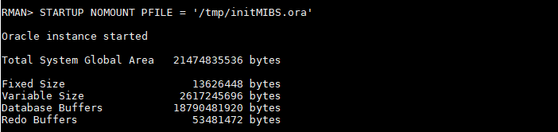

Restore controlfile from '/export/rman/MIBS_ControlFile_20230724_0c223ovr.rman';
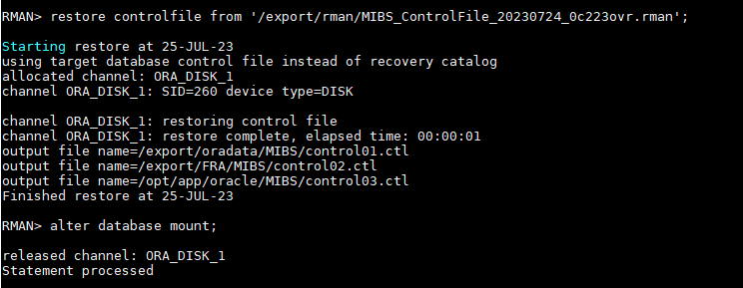

RMAN> alter database mount;

RMAN> report schema;

Starting implicit crosscheck backup at 25-JUL-23
allocated channel: ORA_DISK_1
channel ORA_DISK_1: SID=260 device type=DISK
Crosschecked 5 objects
Finished implicit crosscheck backup at 25-JUL-23

Starting implicit crosscheck copy at 25-JUL-23
using channel ORA_DISK_1
Finished implicit crosscheck copy at 25-JUL-23

searching for all files in the recovery area
cataloging files...
cataloging done

List of Cataloged Files
=======================
File Name: /export/FRA/MIBS/archivelog/2023_07_25/o1_mf_1_842_lcxf6gx4_.arc
File Name: /export/FRA/MIBS/archivelog/2023_07_25/o1_mf_1_843_lcxfmck4_.arc

RMAN-06139: warning: control file is not current for REPORT SCHEMA
Report of database schema for database with db_unique_name MIBS

List of Permanent Datafiles
===========================
File Size(MB) Tablespace RB segsDatafile Name
---- -------- -------------------- ------- ------------------------
1 0 SYSTEM *** /export/oradata/MIBS/system01.dbf
2 0 APPLINDEX *** /export/oradata/MIBS/applindex01.dbf
3 0 SYSAUX *** /export/oradata/MIBS/sysaux01.dbf
4 0 UNDOTBS1 *** /export/oradata/MIBS/undotbs01.dbf
5 0 APPLCOMM *** /export/oradata/MIBS/applcomm01.dbf
7 0 USERS *** /export/oradata/MIBS/users01.dbf
8 0 APPLCOMM *** /export/oradata/MIBS/applcomm02.dbf
9 0 DWHCOMM *** /export/oradata/MIBS/dwhcomm01.dbf
10 0 DWHCOMM *** /export/oradata/MIBS/dwhcomm02.dbf
11 0 DWHINDEX *** /export/oradata/MIBS/dwhindex01.dbf
12 0 WEBBDS *** /export/oradata/MIBS/webbds01.dbf
13 0 WEBBDS *** /export/oradata/MIBS/webbds02.dbf

List of Temporary Files
=======================
File Size(MB) Tablespace Maxsize(MB) Tempfile Name
---- -------- -------------------- ----------- --------------------
1 20 TEMP 32767 /export/oradata/MIBS/temp01.dbf

RMAN> catalog start with '/export/rman/';

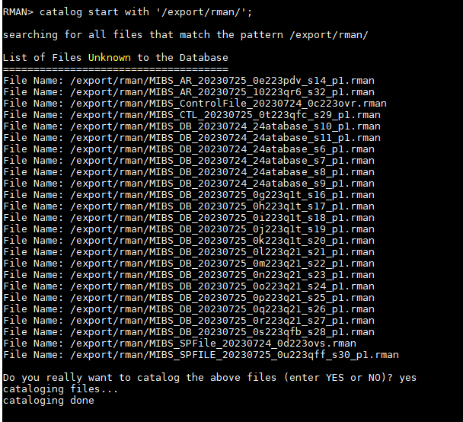

RESTORE THE DATABASE :

RMAN>
run
{
allocate channel ch1 device type disk;
restore database;
switchdatafile all;
switchtempfile all;
release channel ch1;
}

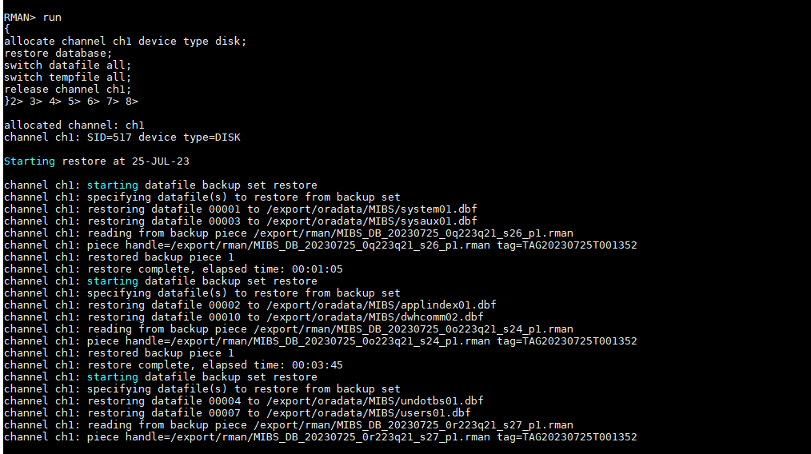

Recover the Database :
RMAN> list backup of archivelog all;
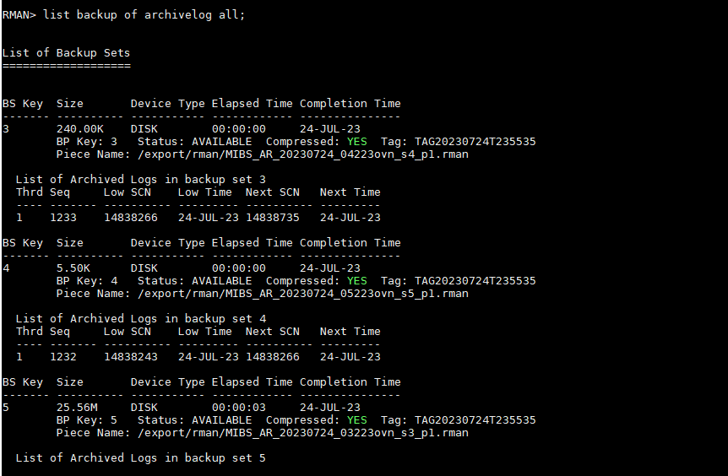

RMAN>
run
{
allocate channel ch1 device type disk;
recover database until scn 14840860;
release channel ch1;
}

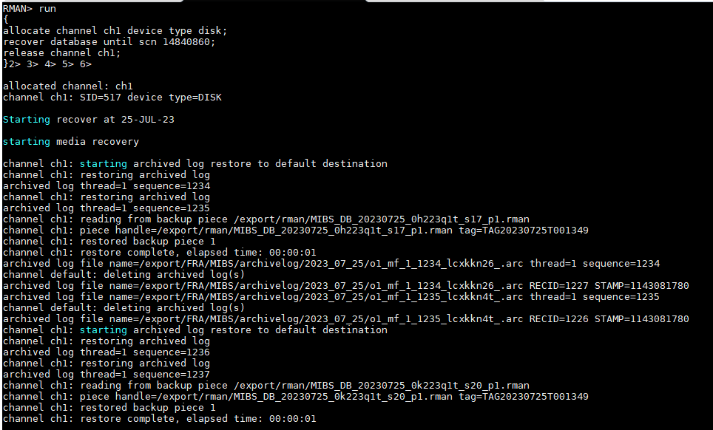

RMAN> alter database open RESETLOGS;
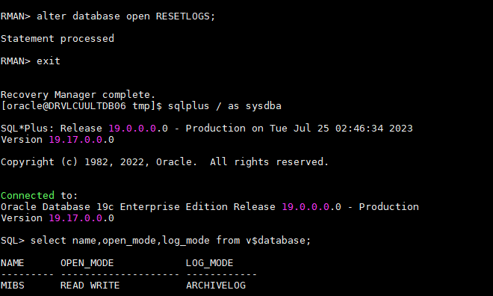
sql> CREATE SPFILE FROM PFILE='/tmp/initMIBS.ora';

Verify DB size in source and target :

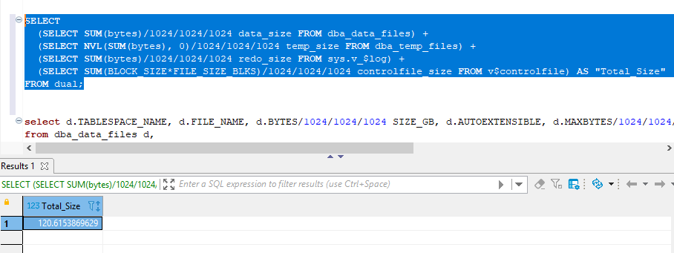

Check Datafiles and Tempfiles :

SQL> select DBID, NAME, DB_UNIQUE_NAME, DATABASE_ROLE, OPEN_MODE from v$database;

DBID NAME DB_UNIQUE_NAME DATABASE_ROLE OPEN_MODE
---------- --------- ------------------------------ ---------------- --------------------
480289968 PROD PROD PRIMARY READ WRITE

SQL>
SQL> select FILE_ID, FILE_NAME, TABLESPACE_NAME, BYTES/1024/1024/1024 "Size In GB" from dba_data_files;

FILE_ID FILE_NAME TABLESPACE_NAME Size In GB
---------- -------------------------------------------------- ------------------------------ ----------
7 /u01/app/oracle/oradata/PROD/users01.dbf USERS .004882813
4 /u01/app/oracle/oradata/PROD/undotbs01.dbf UNDOTBS1 .263671875
1 /u01/app/oracle/oradata/PROD/system01.dbf SYSTEM .869140625
3 /u01/app/oracle/oradata/PROD/sysaux01.dbf SYSAUX .517578125

SQL> select FILE_ID, FILE_NAME, TABLESPACE_NAME, BYTES/1024/1024/1024 "Size In GB" from dba_temp_files;

FILE_ID FILE_NAME TABLESPACE_NAME Size In GB
---------- -------------------------------------------------- ------------------------------ ----------
1 /u01/app/oracle/oradata/PROD/temp01.dbf TEMP .01953125

SQL>
SQL> col MEMBER for a60
SQL> select * from v$logfile;

GROUP# STATUS TYPE MEMBER IS_ CON_ID
---------- ------- ------- ------------------------------------------------------------ --- ----------
3 ONLINE /u01/app/oracle/oradata/PROD/redo03.log NO 0
2 ONLINE /u01/app/oracle/oradata/PROD/redo02.log NO 0
1 ONLINE /u01/app/oracle/oradata/PROD/redo01.log NO 0

=====================================================================================

If DB exists drop DB or create new DB (pfile) to restore:

SQL> select name from v$database; <<--- check database name
NAME
---------
MIBS

SQL> select name from v$datafile;
NAME
--------------------------------------------------------------------------------
/export/oradata/MIBS/system01.dbf
/export/oradata/MIBS/applindex01.dbf
/export/oradata/MIBS/sysaux01.dbf
/export/oradata/MIBS/undotbs01.dbf
/export/oradata/MIBS/applcomm01.dbf
/export/oradata/MIBS/users01.dbf
/export/oradata/MIBS/applcomm02.dbf
/export/oradata/MIBS/dwhcomm01.dbf
/export/oradata/MIBS/dwhcomm02.dbf
/export/oradata/MIBS/dwhindex01.dbf
/export/oradata/MIBS/webbds01.dbf

NAME
--------------------------------------------------------------------------------
/export/oradata/MIBS/webbds02.dbf

12 rows selected.

SQL> select name from v$controlfile;

NAME
--------------------------------------------------------------------------------
/export/oradata/MIBS/control01.ctl
/export/FRA/MIBS/control02.ctl
/opt/app/oracle/MIBS/control03.ctl

SQL> select member from v$logfile;

MEMBER
--------------------------------------------------------------------------------
/export/oradata/MIBS/redo03a.log
/opt/app/oracle/MIBS/redo03b.log
/export/oradata/MIBS/redo02a.log
/opt/app/oracle/MIBS/redo02b.log
/export/oradata/MIBS/redo01a.log
/opt/app/oracle/MIBS/redo01b.log

SQL> shut immediate;
SQL> startup mount exclusive restrict;
SQL> drop database;

